**4.Intelligent Clip**

**1.Preparation**

1.You need to a Clip version HelloBot.

2.You need to a box, which high about 14cm.

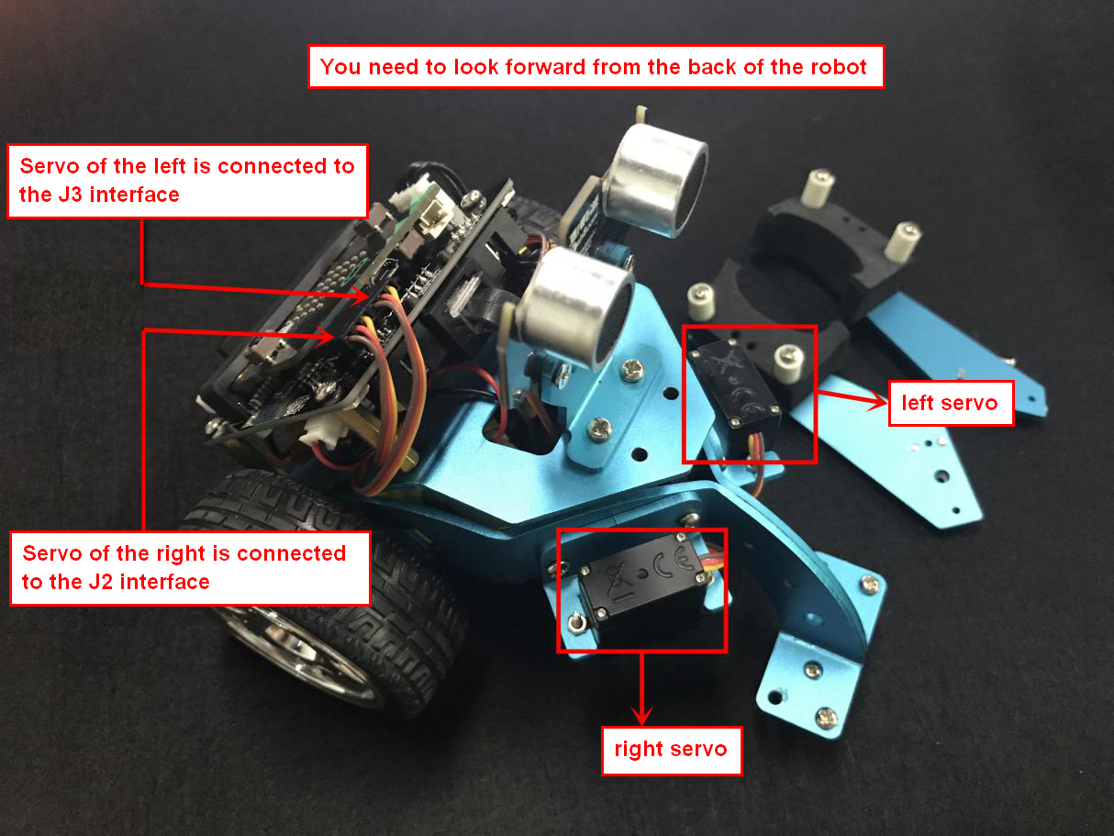

4-1 wiring of metal servo

You need to connect the wiring of the servo to the expansion board, and the servo of the left is connected to the J3 interface and the servo of the right is connected to the J2 interface. The brown line of the servo corresponds to GND, the red line corresponds to VCC, and the yellow line corresponds to IO.

Both the ultrasonic interface and the expansion board interface are designed with anti-reverse connection. The ultrasonic module is connected to the left side of the expansion board by the 4Pin cable.

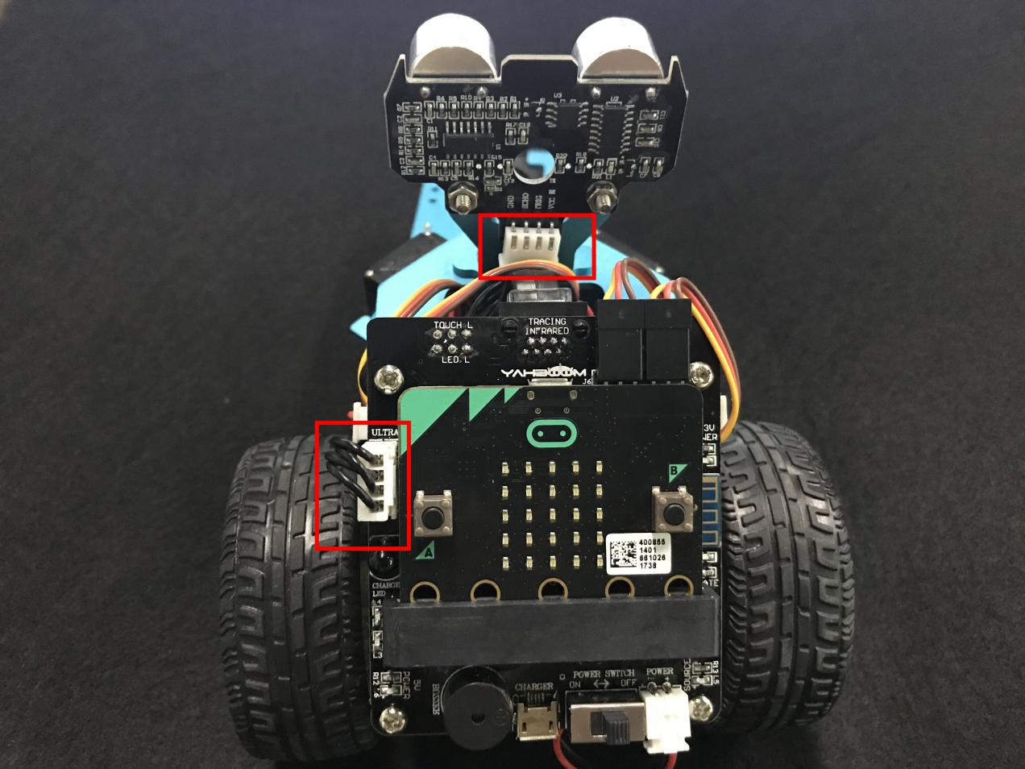

4-2 position of wiring

1. **Learning goals**

In this course, the effect is that if an barrier is detected in front, the robot will clamp the barrier in front.

**3.Programming**

3.1 Programming online

**1) You should use the USB cable to connect the micro:bit to the computer, at this point, the computer will have a micro:bit U disk. You need to open it, click micro:bit website, then entered the micro:bit website** or you can enter the URL directly in your browser: http://microbit.org/

2) After entering the programming interface, you need to click Add package and copy the HelloBot package URL: https://github.com/lzty634158/HelloBot to the input field, click to confirm the add package. Then you can use the blocks of the HelloBot package.

3.2 Programming offline

1) You can double-click to use it. As shown in the following figure.

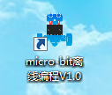

2) After entering the programming interface, you need to click Add package and copy the HelloBot package URL: https://github.com/lzty634158/HelloBot to the input field, click to confirm the add package. Then you can use the blocks of the HelloBot package.

Note: The package only needs to be added once. If you have added packages in the previous lessons, this course does not need to be added repeatedly.

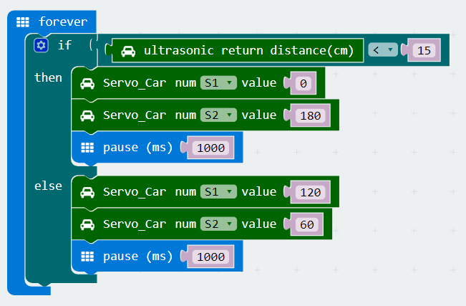

4-3 total program

The locations of blocks in the total program are shown in the following figure.

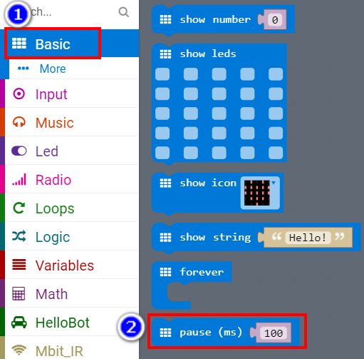

4-4

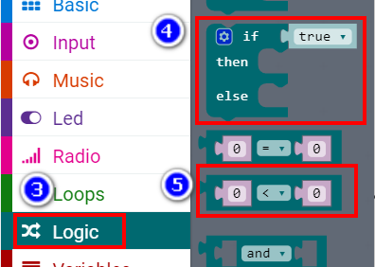

4-5

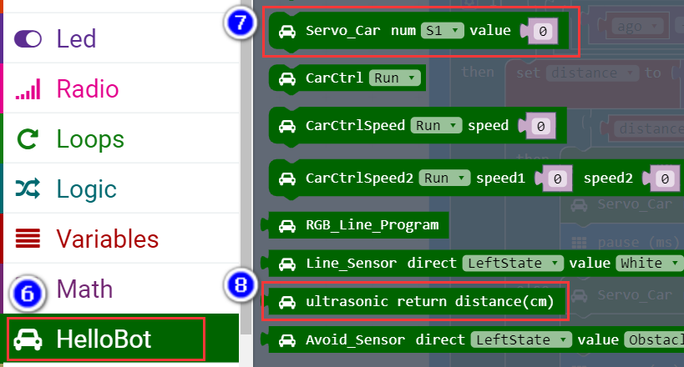

4-6

**4.Download programming**

You need to make sure that the micro:bit development board is connected to the computer. Then you should click on the download in the lower left corner as shown in 4-7 to download the program to micro:bit.

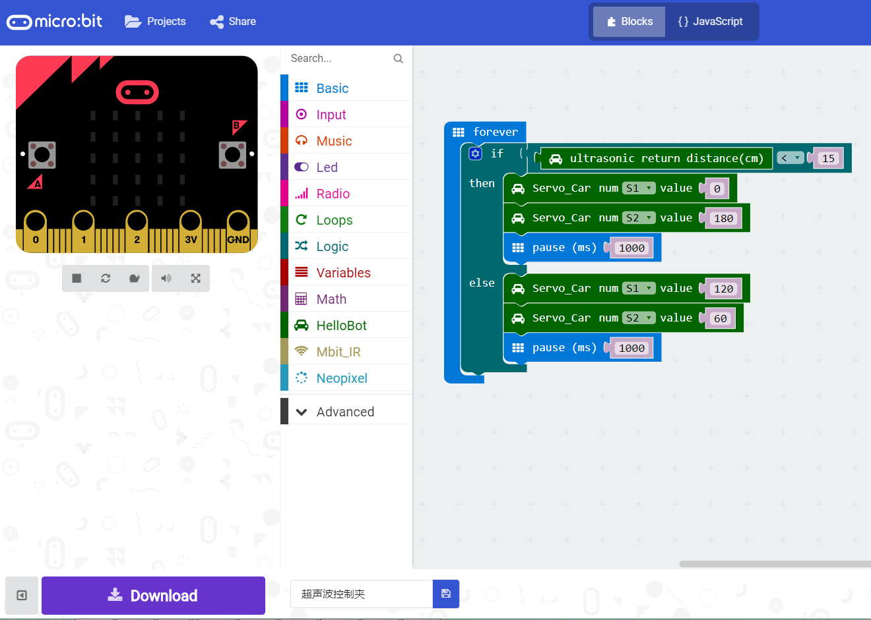

4-7

**5.Phenomenon**

After the code is uploaded. The effect is that if an barrier is detected in front, the robot will clamp the barrier in front. As shown in the figure 4-8. The effect is that if an barrier is not detected in front, the robot will relax. As shown in the figure 4-9.

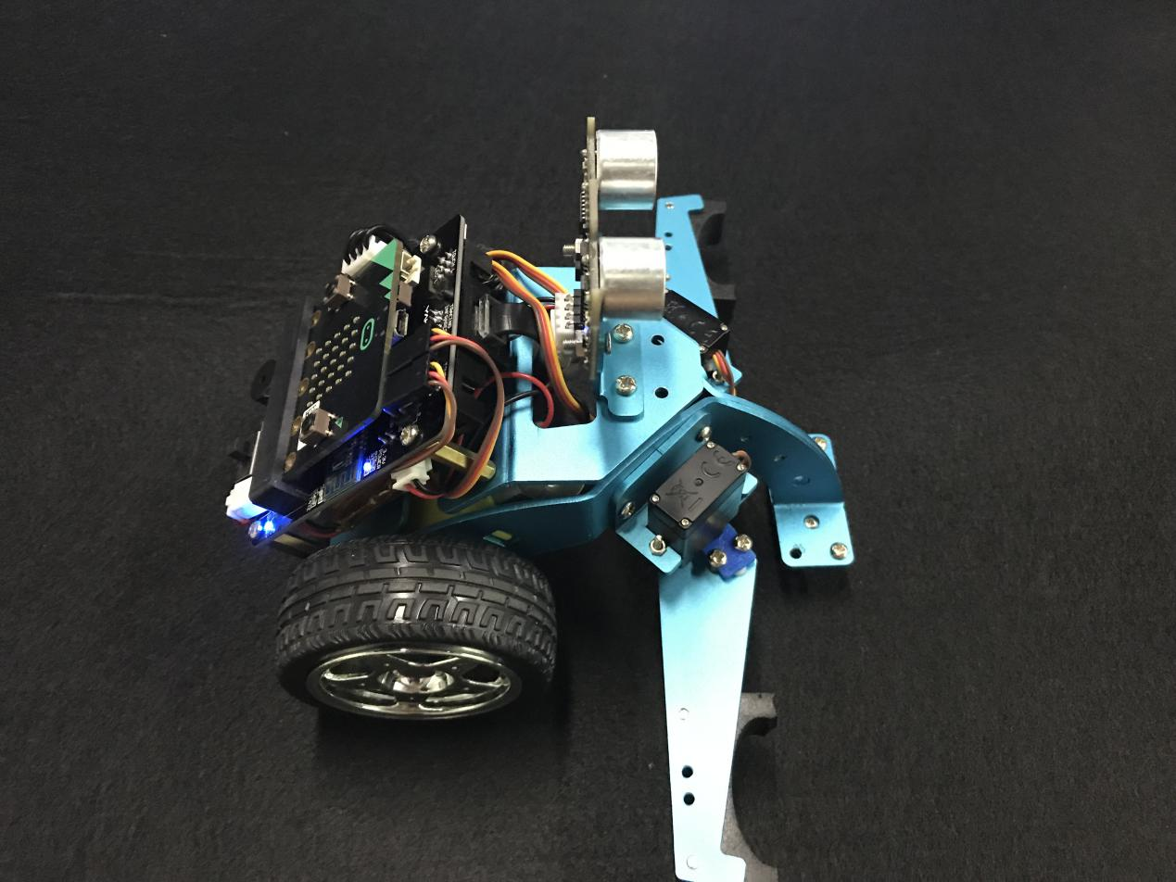

4-8

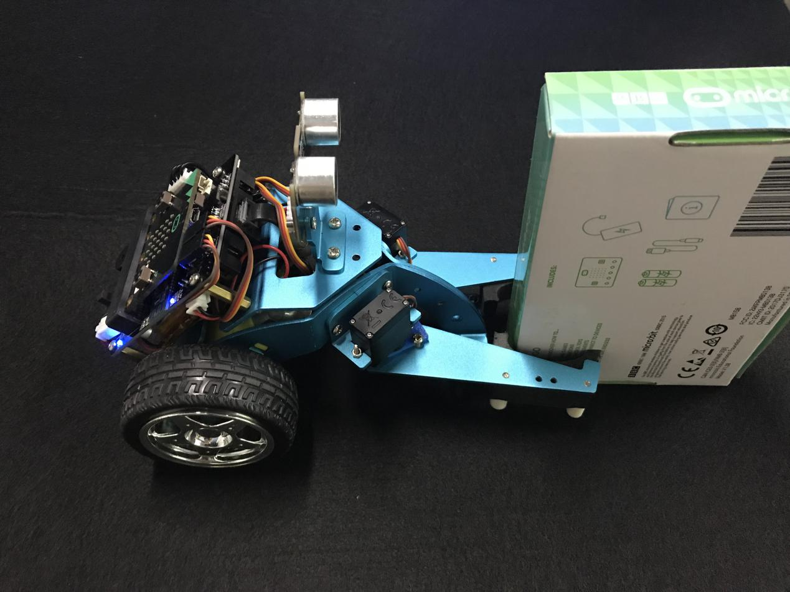

4-9